How is a heated smart mattress topper classified
GERMAN BTI · DEBTI16845/26-1 · CN 9404 90 90
SOURCES CHECKED 11 SEPTEMBER 2026 | Turkey Import Precheck
A German BTI for a Bluetooth-controlled heated topper explains the role of chapter notes and the checks needed before shipping a similar product to Türkiye.

Key conclusion
German customs classified the heated mattress topper described in the decision under CN 9404 90 90. Its heater, sensors and Bluetooth equipment did not automatically place it in Chapter 85 or heading 9032. This finding concerns the specific construction and presentation in the decision; it is not a universal code for smart beds. [1]

What is the product
The article consists of an approximately 8 cm thick topper placed on an existing mattress and a removable cover. Its cellular-plastic body incorporates a textile thermal layer and graphite strips in certain areas. It has four heating zones, NTC temperature sensors, an ambient-air sensor, a timer, a controller and app control via Bluetooth LE. The zipped cover is removable and washable. The decision also mentions an external USB-C power supply and a charger. [1]
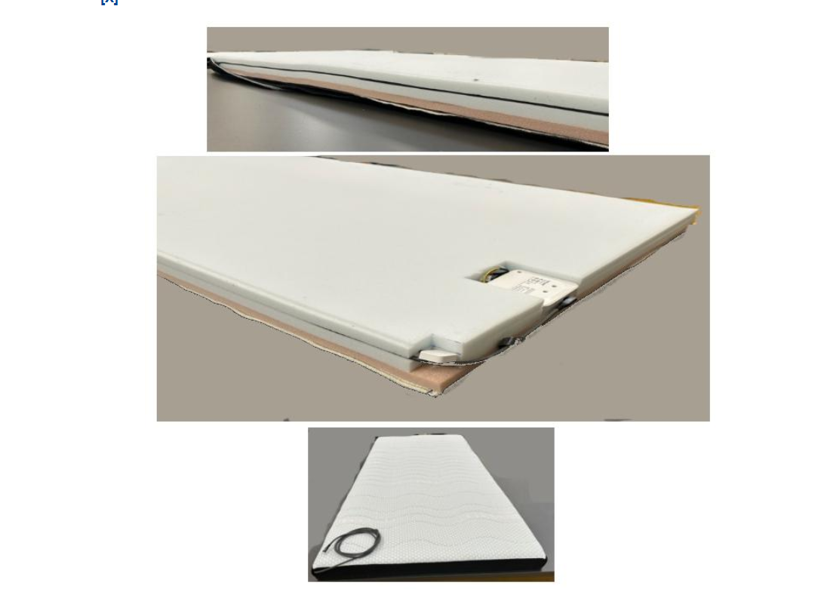
EBTI · DEBTI16845/26-1 · 25/08/2026

Why electrical heating does not place it in Chapter 85
An explicit basis of the decision is Chapter 85 Note 1(a), which excludes certain electrically warmed articles, including blankets and bed pads. Electrical operation alone therefore cannot justify heading 8516. Under General Interpretative Rule 1, the heading terms and relevant section or chapter notes must be applied first. [1, 2, 3]

How the topper and cover were considered together
General Interpretative Rule 3(b) addresses certain composite goods and sets unresolved under Rule 3(a), using the component that gives their essential character. The official description identifies the heated topper as giving the composite article its essential character, considering its use, nature and construction. Reducing the reasoning to ‘the electronics do not matter’ would misrepresent the decision. [1, 3]

Why the sensors and controller do not make the whole article 9032
The official description states that the article meets the conditions for bedding with an electric heating device and is not classified in heading 9032. This conclusion concerns the complete article as presented. A separately presented controller, sensor, adapter or spare part cannot simply inherit its classification. [1]

Distinguishing 9404.21 from 9404.90
A foam construction alone does not settle the subheading. Under General Interpretative Rule 6, subheadings at the same level are compared using their own terms. [3, 4]
HS subheading | Scope
9404.21 | Mattresses of cellular rubber or plastics
9404.29 | Mattresses of other materials
9404.40 | Quilts, bedspreads, eiderdowns and duvets
9404.90 | Other
The German decision describes similar bedding of cellular plastics outside 9404.21–9404.40. Placement on an existing mattress is one distinguishing characteristic. The decision does not establish a thickness rule such as ‘all toppers below 8 cm fall in 9404.90’. [1]

How to use this decision for Türkiye
9404 90 90 is an EU Combined Nomenclature code, not the 12-digit Turkish GTIP required for a Turkish declaration. The binding effect of an EU BTI is defined in relation to its holder, the relevant customs authorities and goods matching the decision. For Türkiye, it is a technical comparison source; it should not be presented as a Turkish BTI or a definitive Turkish code approval. [5]

CE and TAREKS require a separate assessment
The Turkish Ministry of Trade’s 2026 product-group page directs readers to Communiqué 2026/8 for radio equipment and 2026/9 for certain products requiring CE marking. These are review areas for this product, not a finding that it appears in an applicable annex. Assess the Bluetooth equipment, electrical ratings and complete imported configuration, then check TAREKS scope against the rules and annexes in force on the transaction date and the verified GTIP. Classification in 9404 alone does not establish a CE or TAREKS exemption. [6]

Information to prepare before shipment
- Intended use, dimensions, cross-section photos, filling and material composition
- Whether topper, cover, controller and adapter are presented together or separately
- Voltage and power ratings, heating system and Bluetooth module specifications
- Model-matched labels, instructions, declaration of conformity and available test reports
Similar appearance does not prove identical classification. Review the technical file and shipment configuration together. The stated validity period is 31 August 2026 to 30 August 2029; check the decision’s current status again before a transaction. [1, 5]
Send one product / Start pre-check

Official sources
[1] European Commission EBTI — DEBTI16845/26-1
[2] World Customs Organization — HS 2022 Chapter 85, Note 1(a)
[3] World Customs Organization — General Interpretative Rules 1, 3(b) and 6
[4] World Customs Organization — HS 2022 Chapter 94
[5] Union Customs Code 952/2013 — Articles 33 and 34
[6] Turkish Ministry of Trade — Import product-control groups

