TECHNICAL TARIFF CLASSIFICATION REVIEW

Turkish Tariff Classification of a Wearable Health Monitoring Band
  - Comparison of heading 9031 and alternative tariff headings using a German BTI and Turkish BTI records
Record reviewed DEBTI13616/26-1
EU classification CN 9031 80 80
Working code for Türkiye GTİP 9031.80.80.90.19
Last reviewed 9 September 2026
Prepared by Technical team
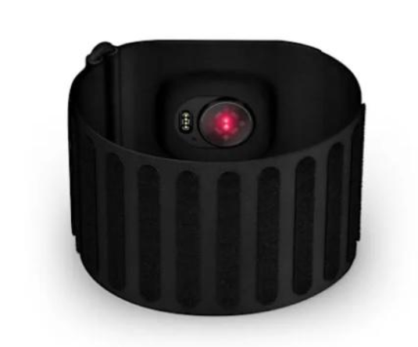
Figure 1 Wearable sensor band shown in the BTI record
Executive conclusion The device was not automatically treated as telecommunications apparatus or a medical device merely because it uses Bluetooth and processes health-related data. The objective function of the screenless product is to measure and record several physiological values. The German customs authority therefore classified it under CN 9031 80 80. The closest 12-digit Turkish working code in the 2026 tariff structure appears to be 9031.80.80.90.19, subject to product-specific verification.

Summary of the decision
Decision DEBTI13616/26-1 examines a retail set consisting of an upper-arm elastic band, a multifunction sensor module, a lithium-ion battery and a USB-C cable. The module contains a PPG sensor, temperature sensor, Bluetooth module and processor. It measures or records heart rate, respiratory rate, pulse, oxygen saturation, skin temperature, sleep duration and sleep quality. Because it has no display, results are viewed in the connected smartphone application.
The key point is that classification follows the product’s objective characteristics at importation, not its marketing name. Bluetooth only transfers data to the phone. Although health-related values are measured, the record does not show that the device was designed for medical diagnosis or treatment. It also has no watch display.
Decision field | Information in the record
BTI reference | DEBTI13616/26-1
Issuing authority | Hauptzollamt Hannover Germany
Date issued | 27 August 2026
Validity period | 31 August 2026 to 30 August 2029
EU CN code | 9031 80 80 Other measuring or checking instruments and apparatus
Main technical characteristic | Measurement of multiple physiological values using PPG and temperature sensors
Interface | No display results are transmitted to the application via Bluetooth

What the EU decision means for Türkiye
According to the Turkish Ministry of Trade, tariff codes used in foreign or EU countries are not binding in Türkiye, although they may guide classification. The Ministry also states that the first six digits should correspond among Harmonized System users and the first eight digits should correspond between the EU and Türkiye. CN 9031 80 80 is therefore a strong starting point, but the Turkish 12-digit GTIP must be determined separately.
Code 9031.80.80.90.19 in this report is a working conclusion. Before it is used in a customs declaration, the product catalogue, intended use, software functions, retail set and current tariff must be reviewed together. Where uncertainty remains material, a product-specific Turkish Binding Tariff Information application is the safest route.

Objective characteristics of the product
A product name alone does not determine tariff classification. Expressions such as smart band, health tracker or wearable sensor can describe technically different goods. The following characteristics appear decisive in this record.
- Elastic upper-arm band measuring approximately 326 x 63.5 x 0.55 mm
- Textile carrier of approximately 70% nylon and 30% elastane
- Electronic sensor module containing a PPG sensor, temperature sensor, Bluetooth module and processor
- Measurement or monitoring of heart rate, respiratory rate, pulse, oxygen saturation, skin temperature and sleep-related data
- No display that directly shows measurement results
- Smartphone application used for setup, control and display of results
- Presented as a retail set with a lithium-ion battery and USB-C cable

Classification logic
1 Heading text and Chapter Notes Under General Interpretative Rule 1, classification begins with the terms of the headings and the relevant Section and Chapter Notes. Heading 9031 is a residual heading covering measuring or checking instruments and apparatus not specified or included elsewhere in Chapter 90.
2 Retail set The band, sensor module, battery and cable are presented together. The decision refers to GIR 3(b) for the set and the component giving it its character, and to GIR 5(b) for the packaging.
3 Multifunction structure The sensor module monitors several values. The reasoning indicates that no single function alone gives the complete product its essential character; GIR 3(c) was therefore applied.
4 Subheading selection Under GIR 6, the subheadings of heading 9031 are compared. The device does not measure geometrical quantities and is not covered by 9031 80 20. It is therefore placed in CN 9031 80 80 for other measuring or checking instruments and apparatus.
The decision refers to the General Interpretative Rules, the EU Combined Nomenclature Explanatory Notes to heading 9031 and the Harmonized System Explanatory Notes. Explanatory notes assist interpretation; the European Commission expressly states that the CN Explanatory Notes are not legally binding.

Why the alternative headings are rejected
Within the same product family, Bluetooth, medical purpose, step counting or watch functions may point to different headings. The table below tests the main alternatives against the objective characteristics in this record.
Candidate | Why it may apply | Why it is weak here | Feature that could change the result
8517 | Data transmission by Bluetooth | Communication carries the measurement result; the objective function is to generate sensor data. | An independent and predominant data-communication function or a communications architecture giving the device its essential character
9018 | Physiological values such as heart rate and oxygen saturation | The record does not establish professional medical use for diagnosis or treatment. | A clear medical purpose, clinical use, electrodiagnostic design or corresponding objective technical characteristics
9029 | Possible association with activity and step counting | The device is not merely a pedometer; it monitors several values through multiple sensors. | Step or revolution counting as the sole or principal function
9102 | Body-worn electronic products may be marketed as watches | There is no display or independent time indication. | Watch character with a suitable display that independently shows time and date
9031 | Multifunction measuring or checking apparatus not specified elsewhere | The sensor architecture and absence of a display support this heading. | A medical, communications or watch function becoming objectively predominant

Smartwatch comparison
Commission Implementing Regulation (EU) 2024/964 classified another wearable device under 9102 12 00. That device measured heart rate and sleep, counted steps and used Bluetooth, but also had a touchscreen AMOLED display and could show time and date without a connected phone. Because the functions were considered equally important, GIR 3(c) was applied and heading 9102, last in numerical order, was selected.
Together, the records show that a display and independent time indication can shift a product from a measuring band to a multifunction watch; the technical structure at importation, not the marketing name, is decisive.

Comparison with Turkish BTI records
The Turkish Ministry of Trade’s publicly available valid BTI records were searched on 9 September 2026 using both product descriptions and official record images. Searches covered smart band, wearable, heart rate, blood oxygen, sleep monitoring, PPG sensor, upper arm, armband, screenless, sensor module and 9031 80. No Turkish BTI record was found for a screenless upper-arm health monitoring band with PPG and temperature sensors matching the German product.
The closest functional record is Xiaomi Smart Band 9. It is strongly similar in heart-rate, sleep and blood-oxygen monitoring. However, it has a 1.62-inch AMOLED display and, after initial setup, performs its watch and other functions without a connected phone. The Turkish BTI classified it under 9102.12.00.00.00. This comparison supports why the screenless German product should not automatically be treated as a watch.
German BTI DEBTI13616/26-1 | 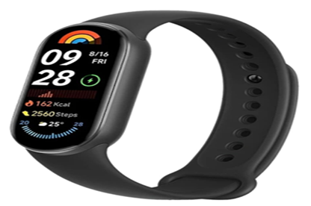  Turkish BTI TR340000260002
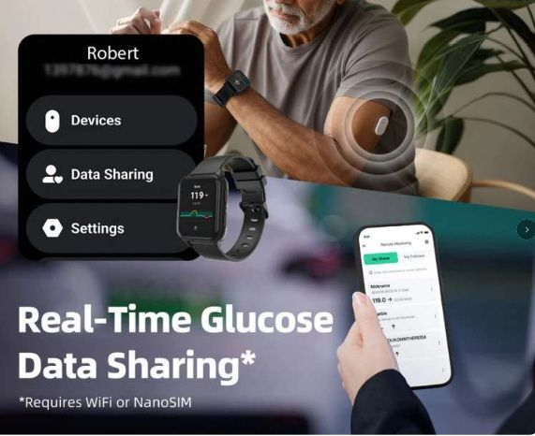  Turkish BTI TR060000250011 | 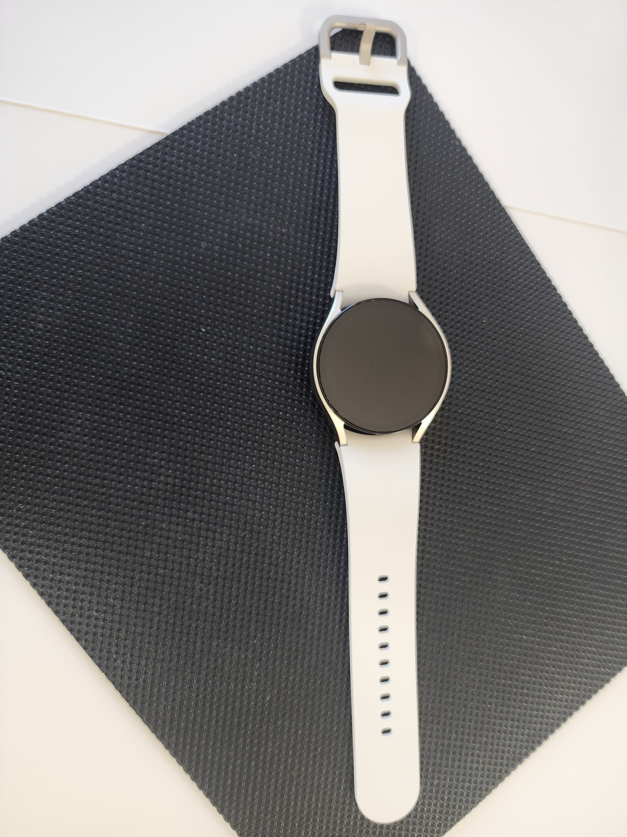  Turkish BTI TR340000240071

Closest Turkish BTI records
BTI and GTIP | Product | Similarity | Why it is not the same precedent
TR340000260002  9102.12.00.00.00 | Xiaomi Smart Band 9 | High functional  Medium visual | It shares most health measurements but has an AMOLED display and a watch function independent of the phone.
TR060000250011  8517.13.00.00.11 | Sibionics SiWatch | Medium functional  Low visual | It has an optical heart sensor and Bluetooth, but SIM, cellular-network and calling functions make communications decisive.
TR340000240071  8517.13.00.00.11 | Samsung Galaxy Watch 6 | Low functional  Low visual | eSIM, LTE, microphone, speaker, internet access and application functions create a predominant multifunction communications-device structure.
TR350000260026  9018.19.90.00.19 | Digitsole Pro Mov Scan Kit | Medium technical  No visual similarity | It includes Bluetooth sensors but is an electro-medical device designed to diagnose and monitor movement disorders.
TR350000230097  8543.70.90.00.19 | RyseUp Wearable 1.0 | Low | It is controlled through an application via Bluetooth; it does not measure, emits PEMF waves and has no medical diagnostic or treatment purpose.

Result of the Turkish BTI search
These records expose three classification boundaries. A display and independent time indication may lead to heading 9102; SIM, calling and predominant communications functions to 8517; and an objective medical diagnostic purpose to 9018. None of those distinguishing elements appears in the German product: it has no display, transfers measurement data to a phone and is not described as intended for medical diagnosis.
A separate search under 9031.80 returned five current Turkish BTI records concerning wheel-speed sensors, ABS sensors and sensors used to measure or check machine parts. Although they share the heading family, their architecture and field of use are too different to be close precedents for the wearable band. The Turkish search therefore does not displace working code 9031.80.80.90.19; it clarifies which features trigger the alternative headings. No BTI issued to a third party is binding for this product owner.

Potential 12-digit Turkish GTIP
The 2026 Turkish Customs Tariff adds national subdivisions and statistical digits after the first eight digits of the EU CN code. The tariff structure provides the following options under 9031.80.80.
Turkish GTIP | Description | Relevance to this product
9031.80.80.10.00 | For use in civil aircraft | The product description does not indicate this use
9031.80.80.90.11 | Load cells | A band with PPG and temperature sensors is not a load cell
9031.80.80.90.19 | Other | Closest national subdivision on the available information

Working conclusion
Based on the available product description and the 2026 tariff structure, the likely Turkish working code is 9031.80.80.90.19, Other. This does not mean that the EU decision applies automatically in Türkiye. The conclusion must be reassessed if the product file reveals a different intended use, a display, a medical claim, an independent communications function or a different condition as imported.

Product file required to confirm the code
- Technical catalogue for the exact model and variant
- Complete list of sensors and communications modules
- User manual and application screenshots
- Functions performed independently of a phone
- Label, packaging and retail-set contents
- Manufacturer’s intended use and marketing claims
- EU Declaration of Conformity and applicable legislation, if available
- Previous import declarations and any existing BTI or Turkish BTI decisions
These documents identify objective characteristics that may change the result, particularly at the 8517 versus 9031, 9018 versus 9031 and 9102 versus 9031 boundaries.

Second-stage checks for import into Türkiye
GTIP is only the first layer. Product-safety controls, permits, taxes and technical-document requirements at import into Türkiye must be checked against the confirmed GTIP, intended use, radio functionality, electrical design, origin and import date.
For a Bluetooth-enabled product, radio-equipment requirements, the CE technical file, declaration of conformity, labelling and Turkish-language instructions may need review. The lithium-ion battery must also be assessed for transport documentation. A product marketed for medical diagnosis or treatment may follow a different regulatory route. None of these questions can be answered solely from code 9031.
The tariff analysis should therefore lead to a separate TAREKS and technical-regulation review. The appropriate next step is a one-product pre-check covering the exact model, catalogue, intended use and available documents together.

Frequently asked questions
Does Bluetooth automatically place the product in heading 8517
No. The question is whether Bluetooth gives the product its essential character. In this decision, the connection carries sensor-generated data to the application.
Does measuring heart rate automatically place the product in heading 9018
Not by itself. Medical intended use and product-specific objective technical characteristics must be assessed separately. Health or wellness marketing is not the same as a medical diagnostic device.
Why is the absence of a display important
It weakens independent watch character and strengthens the product’s measuring-sensor character. A similar product with a display and time indication was classified under heading 9102 in an EU regulation.
Can an EU BTI be used in Türkiye
It is useful as comparative and technical guidance but is not binding in Türkiye. The Turkish 12-digit GTIP must be determined separately.
Is 9031.80.80.90.19 the definitive Turkish GTIP for this product
It is the strongest working code on the available information. A definitive conclusion requires the complete technical file for the imported model and the current rules.

Sources
The decision record, product image, tariff structure and classification reasoning were cross-checked against published EBTI and Turkish BTI records and official tariff sources. The links below provide access to official or primary sources.
1 European Commission EBTI Consultation. Search for decision reference DEBTI13616/26-1.
2 European Commission announcement of the 2026 Combined Nomenclature. Explains the legal basis and application of the 2026 CN from 1 January 2026.
3 Commission Implementing Regulation (EU) 2025/1926. Official text of the 2026 Combined Nomenclature.
4 European Commission explanation of the Combined Nomenclature. Explains the CN code structure and the interpretative role of the explanatory notes.
5 Commission Implementing Regulation (EU) 2024/964. Comparative source for classification of a smartwatch with a display and independent time function under 9102 12 00.
6 Turkish Ministry of Trade tariff FAQ. Official explanation of the GTIP structure, Turkish BTI and the status of foreign tariff decisions in Türkiye.
7 Turkish Ministry of Trade announcement of the 2026 Customs Tariff. Links to the 2026 Turkish Customs Tariff and its official annexes published under Decision No 10781.
8 Turkish Ministry of Trade Binding Tariff Information system. Official database for published Turkish BTI decisions.
9 Turkish BTI image Xiaomi Smart Band 9. Official product image published with Turkish BTI TR340000260002.
10 Turkish BTI image Sibionics SiWatch. Official product image published with Turkish BTI TR060000250011.
11 Turkish BTI image Samsung Galaxy Watch 6. Official product image published with Turkish BTI TR340000240071.

Scope and limitation
This is a technical information paper explaining a published EU BTI record. Another model sold under the same commercial name may have different sensors, software, display, intended use or set contents. This paper is neither a Turkish BTI issued to the product owner nor a definitive tariff determination for a customs declaration.
Last reviewed 9 September 2026 Official sources European Commission and Turkish Ministry of Trade Reviewed by Technical team

